Description
Dribbling to shoot
Category: Technical: Attacking skills
Difficulty: Beginner | Start Time: 22-Feb-2014 08:45h
Session is designed to have players focus on attacking skills and getting to goal with pace and shooting with accuracy at a beginner level
Warm up (5 mins)
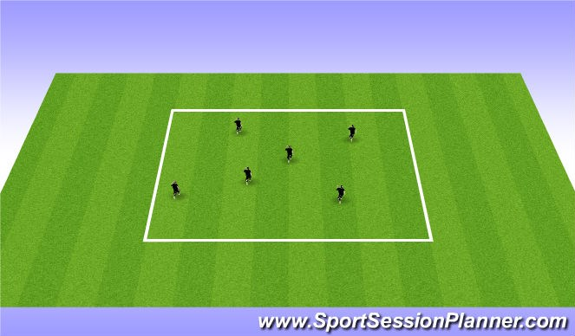
Players start with red light green light: Jogging, sprinting, shuffling, skipping. (use different colors for movements)
Dribbling/start of shooting technique (15 mins)
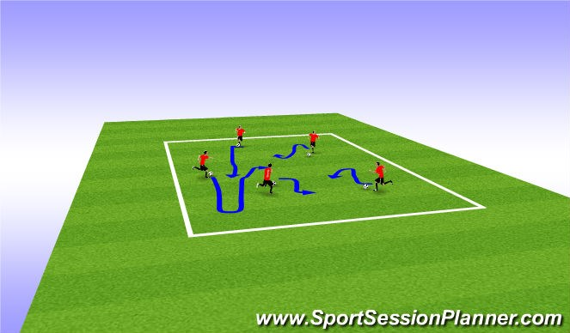
Warm Up with a ball:
Players dribble in coned area work on keeping control of the ball Work on Hitting the ball in the air with the laces (punting) to start the technique of striking the ball with the laces and trying to get the ball strait up in the air.
CP: step ups, Foundation, Scissors, Laces Dribbling, Punting with Laces
Dribbling to shoot (15 mins)
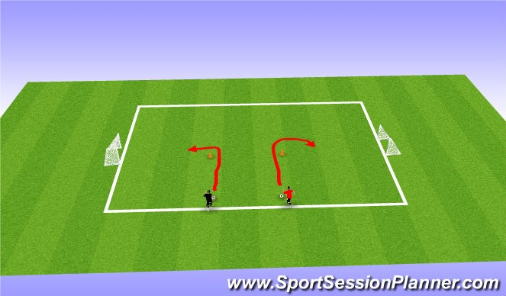
1.Players dribble and use inside cut around the cone then take a shot on goal.
2.Players now race eachother around the cone and try to score first. cp:look for touches to stay close demand the inside cut. make sure players use right and left foot. When shooting encourage with the laces

Game at end (15 mins)
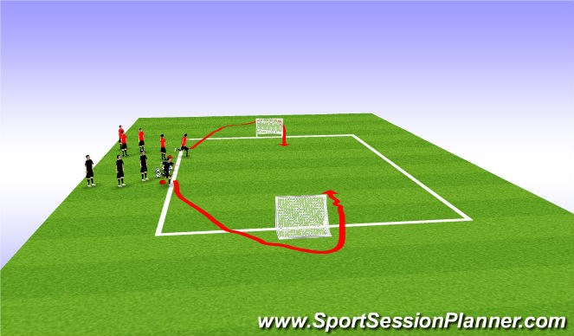
Players play 1v1. Progression 2v2
The players race around the pug goal and come in and play. Ball Is played to the player who is on the field first.
CP: Tell Players to dribble 3x before shooting. If players are advanced enough make them do a move before shooting. Shot must be hit with laces.

